State Institution of Additional Education
«Dokshitsky District Center of Children and Youth»
Institution «Health camp «Beryozka»
Dokshitsky district

We invite you to cooperate within
a humanitarian project.
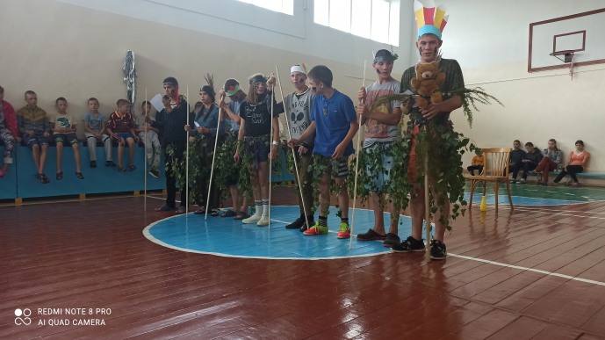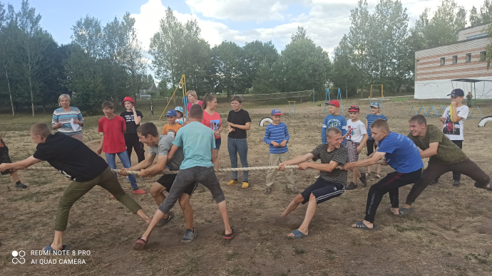
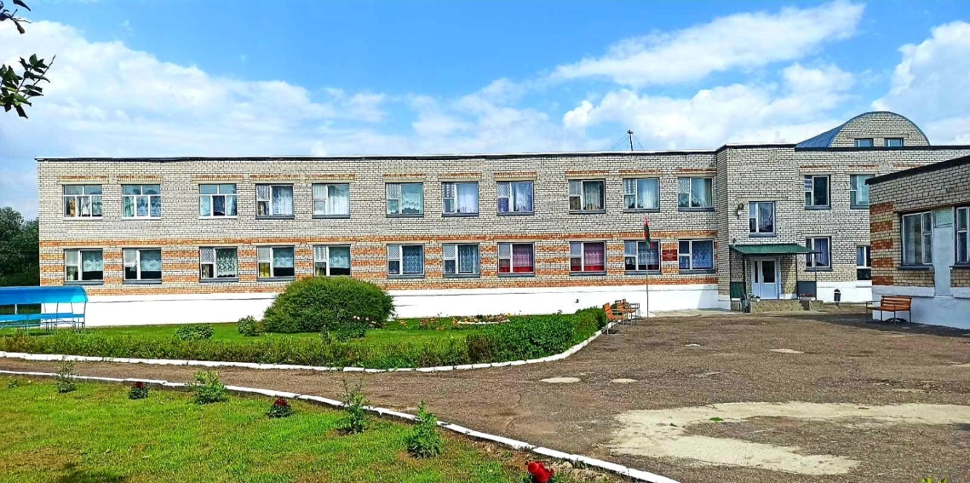
Humanitarian project
«The Rainbow of Friendship»

Implementation period:
from 1 March 2024 to 31 December 2025

2023
1. | Project title: | «TheRainbowofFriendship»
2. | Applicant: | State Institution of Additional Education «Dokshitsky District Center of Children and Youth»
3. | Legal address, telephone, e-mail: | 211722, Vitebsk region, Dokshitsy, Leninskaya Str., 5  Tel. 8 (02157)5-97-90  doksh_cdt@mail.ru
4. | Organization Manager: | Yanukovych Svetlana Antonovna, Director  Working tel.: 8 (02157) 5-97-90  Mob. tel.: +375293181381, +375336979188
5. | Project Manager: | Yanukovych Svetlana Antonovna, Director  Working tel.: 8 (02157) 5-97-90  Mob. tel.: +375293181381, +375336979188
6. | Project goal: | Creation of equal conditions for safe, meaningful, interesting recreation and health improvement of children and adolescents, development of their intellectual, spiritual, physical and creative potential through their involvement in various types of play, cognitive, creative and socially significant activities.
7. | Project objectives: | - to create conditions for the development of creative activity, development and individual abilities and aspirations, self-development and self-expression through the involvement of children and adolescents in a variety of cognitive, creative and socially meaningful activities;  - to promote safe, meaningful health care for children, and an awareness of the value of physical, psychological and social health through education in healthy behaviour and physical development;  - to contribute to the formation of moral ideals, orientations, notions of moral norms and rules of moral conduct through the cultivation of common human values;  - creating a barrier-free, inclusive environment for the successful social adaptation and integration of children with special needs in a health camp with a 24-hour stay;  - developing a tolerant attitude towards children and adolescents with psychophysical development in all inmates of the health camp
8. | Target group: | - children and adolescents aged 6 to 18 years:  - children with special needs;  - childrenfromsubstitutefamilies.
9. | Project duration: | From 1 March 2024 to 31 December 2025
10. | Project location (region/district, city): | Vitebsk Region, Dokshitsky District, d. VitunichiSadovayaSt., 33, structural subdivision of the State Institution of Supplementary Education «Dokshitsky District Center for Children and Youth» institution «Health camp «Beryozka» of Dokshitsky district»
11. | Total funding  (in Belarusian rubles) 126 500
 | Donor funds  (in Belarusian rubles) | 97 000
 | Co-financing  (in Belarusian rubles) | 29 500
12. | Justificationoftheproject | Summer is a long-awaited time for every child. It is a rest time after a busy school year, a time of waiting and learning something new, unknown, vivid impressions and discoveries. For children, summer holidays are a whole world filled with unique colors, interesting meetings, sincere friendship.  In the health camp the child acquires a new social experience, becoming a member of various groups, associations, tries new social roles. His circle of communication is expanding, and by contacting more and more people, the child becomes more independent, acquires experience of independent actions, controls his actions, learns different styles and ways of communication, acquires the skills of conflict-free communication, collaborative ability.  By participating in various creative activities, the child acquires important values and qualities of personality of the future person, citizen and patriot of his country: spirituality, self-respect, honesty, decency, determination, independence, responsibility, sociability and the ability to work in a team, humanity, selflessness, tolerance and charity.  The more diverse the forms of activity of the child, the more social roles it receives and the more versatile it develops. The upbringing and development of children go only in the activity that they accept with their heart and soul, which corresponds to their age, sex, needs.  For teachers, the summer health campaign is a search for new modern approaches in the organization of interesting, useful, full and meaningful rest for children and adolescents. Great opportunities in the organization of such a holiday have country health camps around the clock.  Actuality of development of humanitarian creative project «Rainbow of friendship» is conditioned by the need to create a more attractive educational environment for children and teenagers, contributing to their health improvement, active rest, comprehensive development, social adaptation and self-realization.
13. | Expected results | - general health improvement of children and enhancement of their physical, psychological and social health;  - strengthening friendship and cooperation among children;  - increased activity and willingness to participate in collective creative activities.  - children’s personal growth and development of creative and cognitive abilities;  - acquisition of new knowledge and skills in various fields of activity;  - to enhance the general culture and culture of leisure for children and adolescents.

14. Activities, amounts and outputs

- Task/Activity |  | Amount
Total
amount
(in Belarusian rubles)

 |  | Donor funds  (in Belarusian rubles) | Co-financing, (in Belarusian rubles)
Task I
- create conditions for the development of creative activity, individual abilities and aspirations, self-perfection and self-expression, the formation of moral ideals, Orienting, cultivating universal human values through the involvement of children and adolescents in diverse cognitive, creative and socially meaningful activities
1. | Activity 1.  Organizational work on the staff formation and inmates of the health camp with 24-hour stay |  | 2500 | 2500
1.1. | Training seminars for staff on the organization of summer recreation for children and adolescents in a health camp with 24-hour stay |  | 2000 | 2000
1.2. | Publication and placement of advertising products about the activity of the recreation camp «Beryozka» |  | 500 | 500
2 | Activity 2.  Organizing of activities of interest associations |  | 4000 | 4000
2.1. | Openingofsportsassociations |  | 2000 | 2000
2.2. | Openingofartisticassociations |  | 2000 | 2000
3. | Activity3.  Organizingthe health camp’s educational process | 22000 | 11000 | 33000
3.1. | Organizing and conductingmass events with pupils according to the work plan | 10000 | 6000 | 16000
3.2. | Organizing of tourist and excursion activities | 12000 | 5000 | 17000
Task II
• To promote the safe and wholesome recovery of children, the development of awareness of the importance of physical, psychological and social health, healthy behaviour and physical development; creating a barrier-free, inclusive environment for successful social adaptation and integration of children with special needs in health camp settings
4 | Actvity 4.  Physical development, tempering and organizingof vitamin balanced nutrition of health camp pupils | 75000 | 12000 | 87000
4.1. | Carrying out exercises, mobile games and outdoor sports activities |  | 3000 | 3000
4.2. | The stadium reconstruction | 35000 |  | 30000
4.3. | Water hardening procedures and summer outdoor shower equipment |  | 3000 | 3000
4.4. | Fencing of the recreation camp | 15000 |  | 15000
4.5. | Pavement of the street with curbs | 25000 |  | 20000
4.6. | Wide use of fresh vegetables and fruit when cooking |  | 6000 | 6000

